Chapter 10, Problem 9.

Use nodal analysis to find v_{o} in the circuit of Fig. 10.58.

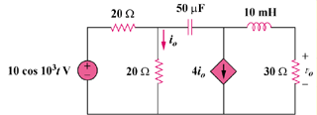

Figure 10.58
For Prob. 10.9.

